**Project Design Phase-II**

**Data Flow Diagram & User Stories**

|  |  |
| --- | --- |
| Date | 12 October 2022 |
| Team ID | PNT2022TMID41953 |
| Project Name | Hazardous area monitoring for Industrial plant powered by IoT |
| Maximum Marks | 4 Marks |

**Data Flow Diagrams:**

A Data Flow Diagram (DFD) is a traditional visual representation of the information flows within a system. A neat and clear DFD can depict the right amount of the system requirement graphically. It shows how data enters and leaves the system, what changes the information, and where data is

stored.

**Example:** [**(Simplified)**](https://developer.ibm.com/patterns/visualize-unstructured-text/)

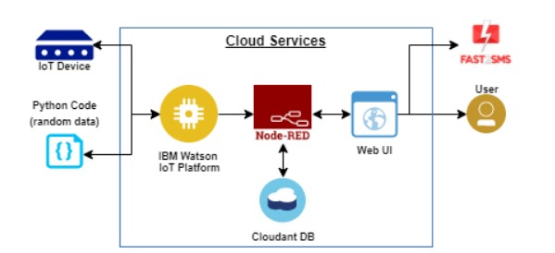

1.consort IoT device with python code.

2.IBM Watson understanding the language and send Node RED.

3.In cloud services, cloundant DB ,Web UI are also there and it connect into user.

4.Send the notification to the user as a Fast SMS.

DFD Level 0 (Smart hazardous area monitoring)

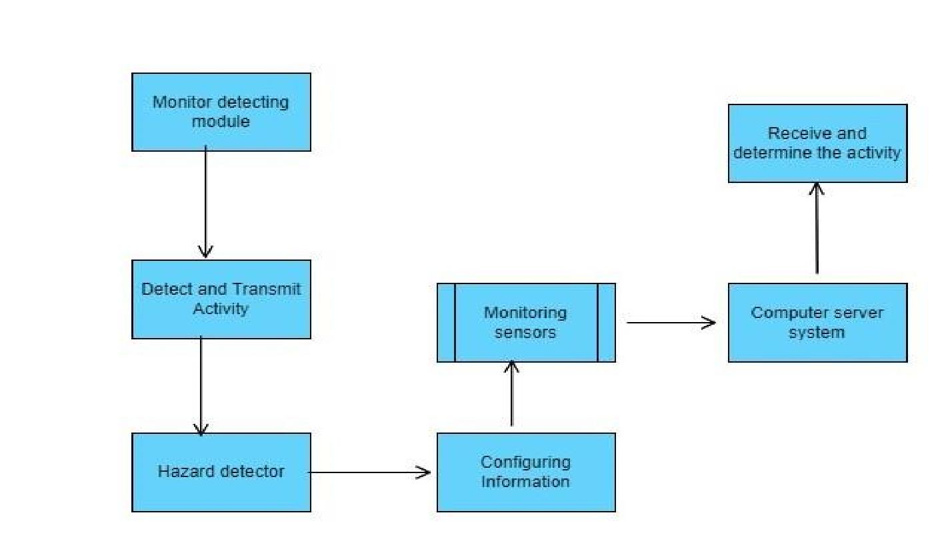

**User Stories**

Use the below template to list all the user stories for the product.

|  |  |  |  |  |  |  |
| --- | --- | --- | --- | --- | --- | --- |
| **User Type** | **Functional**  **Requirement**  **(Epic)** | **User Story Number** | **User Story / Task** | **Acceptance criteria** | **Priority** | **Release** |
| Customer  (Mobile user) | Registration | USN-1 | As a user, I can register for the application by entering my email, password, and confirming my password. | I can access my account / dashboard | High | Sprint-1 |
|  |  | USN-2 | As a user, I will receive confirmation email once I have registered for the application | I can receive confirmation email & click confirm | High | Sprint-1 |
|  |  | USN-3 | As a user, I can register for the application through Facebook | I can register & access the dashboard with Facebook Login | Low | Sprint-2 |
|  |  | USN-4 | As a user, I can register for the application through Gmail | I can receive confirmation mail | Medium | Sprint-1 |
|  | Login | USN-5 | As a user, I can log into the application by entering email & password | I can view my application | High | Sprint-1 |
|  | Dashboard | USN-6 | As a user , I can view my dashboard to analyse my work | I can view my performance level | High | Sprint-2 |
| Customer (Web user) | Sign up | USN-7 | As a user ,I can sign up into the website by my user name and password | I can visit that application through as a web user | Medium | Sprint-1 |
| Customer Care Executive | Deal with Customer | USN-8 | I can deal and make a connection with customer care executive | I can learn through customers | High | Sprint-2 |
| Administrator | Examine | USN-9 | I can inspect the problem with these requirements | I can executive the functions of the system | High | Sprint-2 |